**Assignment 1 on Angular**

1. Create application Structure by using angular-cli

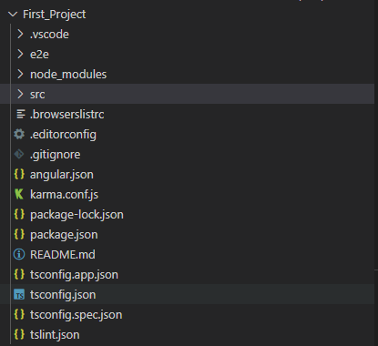

1. Create component

* Admin
* Menu
* Restaurant
* User

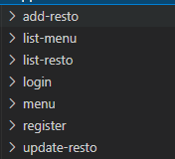

1. Implement routing

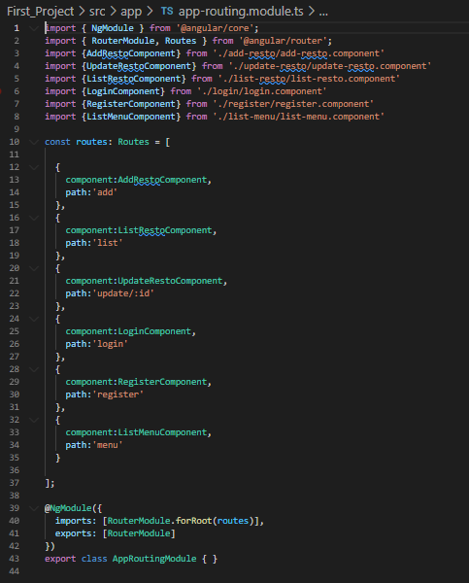

1. Admin Module

* Create Dashboard containing two tiles.

Menu

Restaurant

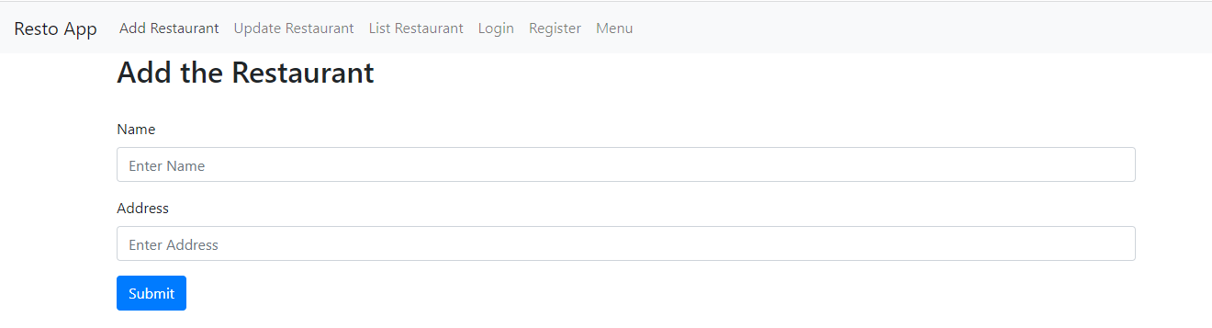

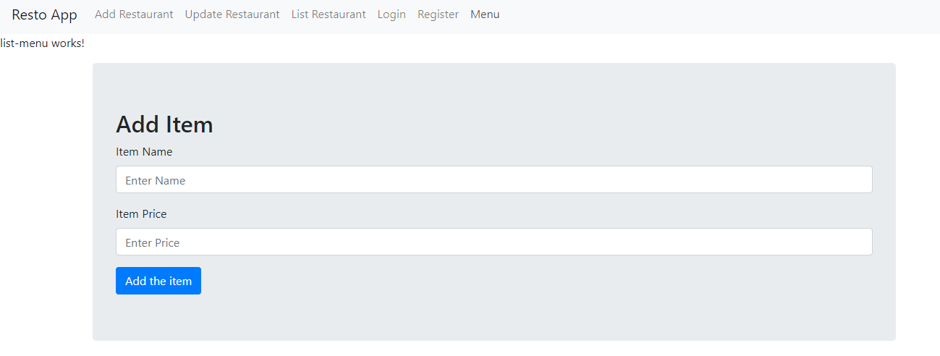

1. Menu Module

* Menu List Table containing ( Add / Edit / Delete)
* Only admin can add, edit and delete menu
* Restaurant owner can view menu.
* Create one section to assign menu to restaurant.

1. Restaurant Module

* Restaurant List Table containing ( Add / Edit / Delete)
* Only admin can add, edit and delete Restaurant
* Restaurant owner can view menu.

1. User will place order by using dashboard.

* Display restaurant List
* User will choose restaurant
* Display menu according as per selection of restaurant
* Select Menu
* Place the orders
* Confirmation Page ( If success, if fails then show message according )

